**HANOI UNIVERSITY OF SCIENCE AND TECNOLOGY**

**SCHOOL OF ELECTRICAL AND ELECTRONIC ENGINEERING**



**MIDTERM PROJECT – SEMESTER 2022.2**

**SUBJECT: MICROCOMPRESSOR AND COMPUTER ARCHITECTURE**

**Class: 141007**

**NGUYỄN PHÚ MINH NHẬT - 20202795**

**nhat.npm202795@sis.hust.edu.vn**

Table of contents

**1.** **Design hardware** 3

**1.1.** **Request a topic** 3

**1.2.** **Choose components** 3

**2.** **Schematic of project** 3

**3.** **Flow chart of project** 4

**3.1.** **Flow chart of main function** 4

**3.2.** **Flow chart of control motor function (Timer interrupt service routine)** 5

**3.3.** **Flow chart of LCD write function** 7

**3.4.** **Flow chart of the ADC read function** 9

**4.** **Advantages and disadvantages of the project** 10

**4.1.** **Advantages:** 10

**4.2.** **Disadvantages:** 11

**4.3.** **Future improvement** 11

**More details about the project:** https://github.com/Nhatkhongbuon/ASM_8051_ADC0804_LCD_LM35_L298.git 11

1. **Design hardware**
   1. **Request a topic**

* Design a system for measuring and monitoring environment temperature, having: MCU 8051, analog temperature sensor. Display the measured temperature value information on the LCD. Motor control with 3 rotational speeds, operating with 2 modes: auto mode and manual mode.
  1. **Choose components**

Following the request of topic, choose the following components:

* Microcontroller 8051
* LM35 sensor (analog temperature sensor)
* LCD 16x2 (HD44780U)
* DC motor
* Motor driver L298 (H-bridge motor driver)
* ADC0804
* Button, respack-8, resistor, pot…

Advantage: All of components are cheap, popular and easy to program.

1. **Schematic of project**

1. **Flow chart of project**
   1. **Flow chart of main function**

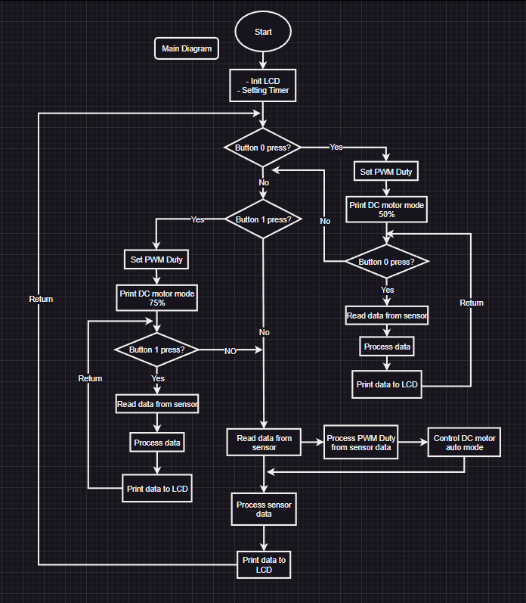

In this project, I use the polling method to program. First, we check the button 0, if it is pressed, the DC motor runs in mode 1 (in this project I program mode 1 DC motor runs with PWM duty = 50%). The program continuously checks the state of the button, if it is still pressed, the DC motor still runs in mode 1. Similar to mode 1, if button 1 releases and button 2 is pressed, the DC motor run in mode 2 (PWM duty = 75%). In both buttons are released, the DC motor runs in auto mode, PWM duty in this case depends on measured temperature (ex: 50^o C = 50%). In auto mode, the program continuously checks button 0 and button 1.

The measured temperature and notifications of DC mode are printed on LCD.

* 1. **Flow chart of control motor function (Timer interrupt service routine)**

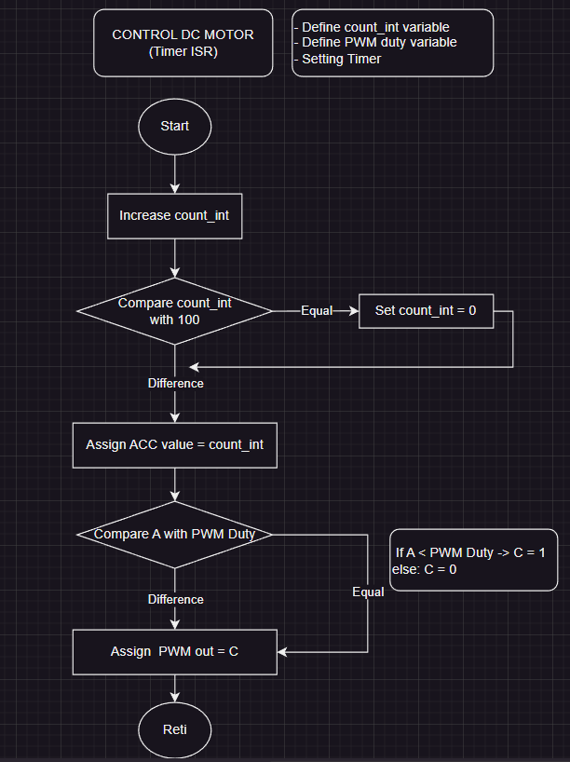

In this case, we use a count variable, first thing we do is compare a count variable with 100. This means we divide 1 cycle into 100 parts (if we set timer count 100 times, with T of MCU = 12MHz, so final T = 100.100.1us). Check the count variable, if it equals 100, set it equal to 0 to start counting again.

Next, we use compare function to build timer ISR to control the DC motor with PWM duty (PWM duty is the percentage that the pulse is high for 1 cycle) is programmed, if the count variable less than PWM duty, MCU generates a high pulse or vice versa. But in ASM language doesn’t have to compare functions, so we use CJNE instruction (compare jump not equal)A screenshot of a computer code

We can see in this fig, CJNE affects the carry flag. If A < PWM duty so C = 1, in other case A > PWM duty so C = 0. Using that effect, we can pulse width modulation.

Function in the project:

* 1. **Flow chart of LCD write function**

Timing diagram of LCD:

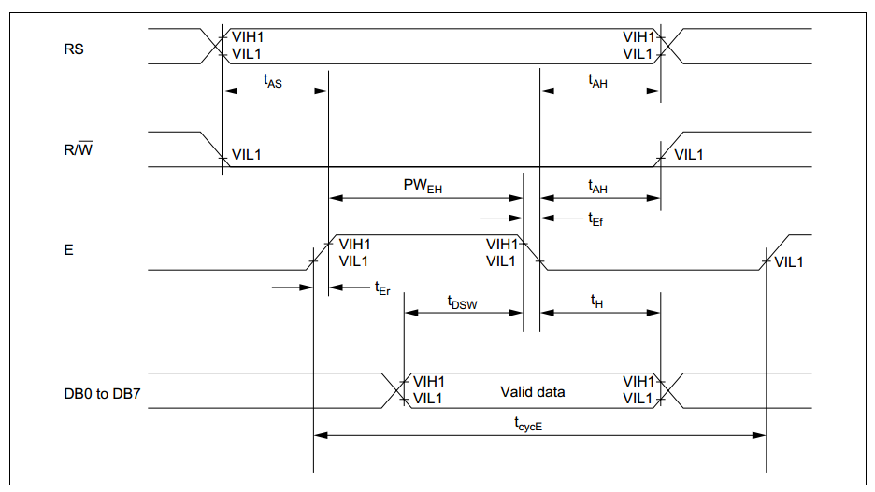

Based on the timing diagram we have flow chart of LCD write function:

In the following flow chart, I check that MCU wants to write data or instructions. But in my project, I split it into two functions write data and write instructions.

Functions in project:

* 1. **Flow chart of the ADC read function**

Timing diagram of ADC 0804

Based on the timing diagram we have flow chart of ADC read data function:

Function in the program:

1. **Advantages and disadvantages of the project**
   1. **Advantages:**

* The functions in the project are very simple and can be reused easily.
* Pulse hash function is the best point of the project.
  1. **Disadvantages:**
* Using too many microcontroller pins.
* High frequency pulses (KHz) cannot be hashed, an error will occur.
* Minus temperature has not been measured
  1. **Future improvement**
* Use communication methods other than LCD like 4bit or I2C
* Pulse hash function improvements

# **More details about the project:** https://github.com/Nhatkhongbuon/ASM_8051_ADC0804_LCD_LM35_L298.git